Beyond Line-of-Sight UHF Digital Communications with the LoRa Spread Spectrum Waveform

How to use amateur radio VHF+ DX techniques to set a LoRa communications world record

Dan Fay, KG5VBY
daniel.fay@gmail.com

Abstract

Semtech's LoRa transceiver products, based off Chirp Spread Spectrum (CSS) modulation, provide high receive sensitivity for low-power, Internet-of-Things (IoT) devices. While Semtech's LoRa transceivers are designed to provide Line-of-Sight (LoS) ranges of several miles with modest radio hardware (i.e., small duck antennas, and 25-100mW Tx power levels), the high receive sensitivity (up to -138dBm or more) of a LoRa transceiver allows for leveraging common VHF+ DX techniques to achieve ranges beyond radio line-of-sight. By using higher power levels (5W/37dBm or more), high gain antennas (14.8dBi base station Yagi, 12.4dBi mobile Yagi), and horizontal polarization, it is possible to achieve Beyond Line-of-Sight (BLoS) packet radio communications using LoRa on the 70cm band. This paper will discuss digital communications using the LoRa waveform, how BLoS communication is achieved at VHF+ frequencies, the experimental setup used in this paper, and the real-world test results. To the best of the author’s knowledge, the 218km LoRa ground-based LoRa communications distance discussed in this paper is the longest ground-based (ground station-to-ground station) LoRa communication on record.

Keywords: LoRa, spread spectrum, packet radio, troposcatter, diffraction

Introduction

This section will first provide an overview of Semtech’s LoRa waveform and LoRa-based products. It will then discuss the different propagation methods used by VHF+ DXers to perform BLoS communications. In discussing these techniques, this section will discuss why the LoRa waveform is well-suited for performing the weak-signal VHF+ communications inherent to diffraction- and troposcatter-based BLoS communications. It will also outline the diffraction and troposcatter propagation methods used to perform these long distances experiments.

The Semtech LoRa Waveform

LoRa is a proprietary waveform produced by Semtech for various low-power RF transceiver products. It uses a form of spread spectrum called Chirp Spread Spectrum (CSS) to provide very high receive sensitivity at low data rates. Semtech targets the LoRa products for Low-Power Wide Area Networks (LPWANs), which are low-speed networks designed to provide low-power sensors a long-range way to wirelessly communicate. It is typically used on unlicensed bands in the 915MHz (US, Australia, and others), 868MHz (EU), 433MHz (EU and China), and 470MHz (China). LoRa, by itself, only provides for the physical and parts of the link layer needed for network communication. To provide a network stack for sensor nodes to communicate, Semtech has developed the LoRaWAN protocol, which provides features such as channel management and data encapsulation to the basic LoRa waveform.

LoRa communications is based on a form of spread spectrum communications called Chirp Spread Spectrum (CSS). CSS uses chirps (emissions that go up or down in frequency) to encode data. An upchirp is a mark, and a downchirp is a space with LoRa’s CSS modulation. LoRa communications are specified in terms of two different parameters: the bandwidth of the chirps, and the spreading factor. Higher bandwidths allow for a higher baud rate for a given spreading factor at the expense of lower receive sensitivity. Lower spreading factors allow for higher data rates at the expense of receive sensitivity. Another parameter that affects the data rate is the coding rate, or how much data is devoted to a Hamming-code-based EDAC. While the datasheets for Semtech’s products show support for a large variety of bandwidths, bandwidths of 500KHz, 250KHz, and 125KHz are the most commonly used bandwidths. Baud rates below 300bps are typically not used, as the narrow bandwidths and long transmit times require a TCXO to minimize frequency drift.

Semtech produces two major LoRa product lines: one for 2.4GHz operation, and one for sub-GHz operation. The 2.4GHz products, the SX1280 and SX1281, support frequencies between 2400MHz-2500MHz. The 2.4GHz products, while potentially interesting for various reasons (including ranging support), are relatively new and do not currently exist in many products. This paper exclusively discusses the sub-GHz products due to their greater maturity and larger market penetration. Semtech’s combined sub-GHz product line can cover any amateur radio band from 2m to 33cm. Actual shipping LoRa products, however, are targeted at various global unlicensed ISM bands. As a result, LoRa-using products typically target one of the following bands: 169MHz (China), 433MHz (mainly EU and China), 470MHz (China), 315MHz (China), 868MHz (EU), and 915MHz (US, Australia, India, etc.). LoRa modules for 2m and 1.25m are possible with Semtech’s transceivers but would require a specific effort by the amateur radio community to develop custom LoRa board designs for use on these frequencies.

BLoS on VHF+ Frequencies

VHF and higher frequencies do not reliably refract from typical ionization in the ionosphere. As a result, VHF-and-higher frequencies are either assumed to be Line-of-Sight (with perhaps an additional 33% distance beyond the radio horizon due to curving around the Earth’s surface) or utilize some other, more exotic propagation method. Sporadic E (Es), involving strongly-ionized clouds in the ionosphere, is often used by radio amateurs communicating on the 6m and 2m bands. Meteor scatter (also known as meteor burst) involves using ionized trails from meteors entering the Earth’s atmosphere to establish short-duration communications. Meteor scatter is typically used with 6m and 2m. Moonbounce (also known as Earth-Moon-Earth, or EME) communication reflects radio waves off the Moon to communicate at a wide variety of frequencies. It is highly challenging to use because of the very high path losses. When an inversion occurs in the troposphere, it is possible that the inverted layers of air can form a waveguide that allows for very effective communication at VHF+ frequencies. This propagation method is called tropospheric ducting.

The two BLoS techniques studied in this paper are diffraction and troposcatter. These techniques are less known for two reasons. First, they are essentially only useful for medium DX distances. At best, troposcatter allows for communications up to about 700km, with diffraction being limited to even shorter distances. Second, they require a substantial link budget that requires high receive sensitivity, high transmit power, and high antenna gain. As a result, the omnidirectional antennas and FM modulations frequently used at 2m, 1.25m, and 70cm typically do not have the excess link budget necessary to make these modes work well. Generally, radio amateurs who work diffraction and troposcatter DX use high gain beam antennas with more sensitive modes such as SSB, CW, and robust digital modes such as PSK31 and the WSJT-X weak signal modes.

Diffraction involves small quantities of RF radiation being diffracted past the radio horizon. Diffraction can take the form of either knife-edge diffraction occurring around relatively “sharp” objects or terrain features or smooth earth diffraction around the Earth’s surface. Smooth earth diffraction is generally a weaker effect than knife-edge diffraction. Diffraction is generally useful for shorter distance BLoS. At longer distances, troposcatter provides BLoS propagation by scattering radio waves off irregularities in density and moisture in the upper troposphere. Troposcatter is a reliable communication method, but its effectiveness does vary based on weather conditions and can suffer from fast fading issues.

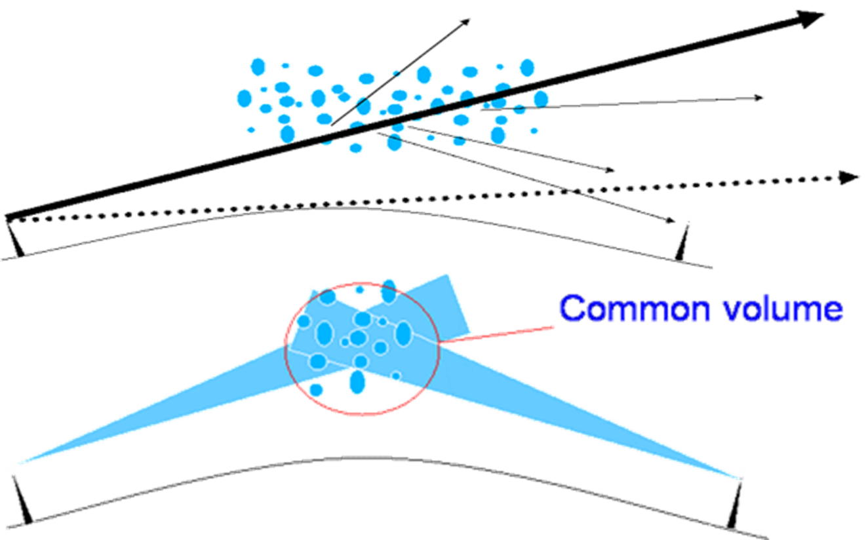
Figure 1: Overview of troposcatter propagation.
Successfully utilizing diffraction and troposcatter for BLoS communication requires a large link budget to account for the massive path loss involved. Typically, for troposcatter, the troposcatter propagation component adds at least an additional 60 dB path loss in addition to the line-of-sight path loss. Typical total path loss is at least 160-170dB for troposcatter communications. As a result, successful troposcatter communication requires a combination of high transmit power, large antenna gain, and high receive sensitivity. LoRa, with its receive sensitivity of up to -148dBm, provides the potential to successfully accomplish troposcatter communications if the antenna gain and/or power levels are sufficiently high.

Another important aspect of troposcatter communications is the angle of radiation that the antenna transmits at. For troposcatter, it is critical for the antenna has a radiation angle that is as close to level as possible. Each degree above the horizon increases the path loss by roughly 10dB. Not only does this mean that the antenna should be level and pointed to the horizon, it should also be elevated roughly 7-10 wavelengths above the ground. Another major factor increasing the radiation angle are objects like mountains, hills, buildings on the horizon. Ideally, the path between both stations should be clear and flat.

Typically, for weak-signal VHF+ DXing, horizontal polarization is used. While horizontal polarization may offer some advantages in terms of ground gain and perhaps less noise, it is not clear whether horizontal polarization provides any inherent advantages over vertical polarization. Commercial troposcatter systems use both vertical and horizontal polarization to provide additional diversity. This paper studied LoRa communications using horizontal polarization mainly because it is the established polarization type for VHF+ DXing. Future work will compare vertical polarization to horizontal polarization for LoRa BLoS communications.

Experimental Setup

This section discusses the test setup used to investigate BLoS LoRa communications. It first discusses the high-power, 433MHz transceivers used, and analyzed the specific LoRa parameters the transceivers use. It then discusses the antennas used along with the specific weatherproof and mobile physical setups employed for the experiments. Next, the section discusses the higher-level IP-based communications used. Finally, the total link budget for the different test platforms are calculated, and an RF coverage model is obtained and discussed.

Transceiver Setup

At the heart of these LoRa troposcatter experiments are LoRa modules produced by Chengdu Ebyte Electronic Technology Co, Ltd (CDEByte). Based out of Chengdu, China, they produce various lines of wireless modules designed for Internet-of-Things (IoT)-like applications. For these experiments, their E32 DTU line was chosen. CDEByte appears to market them as wireless bridges for the Modbus industrial fieldbus protocol. To facilitate their industrial use, the DTU devices possess several features also useful for this study: flexible support for different supply voltages (10-36V), RS232 and RS485 serial support, and a rugged metal chassis. To provide a wireless Modbus bridge, the E32 series is designed to operate as a transparent, half-duplex serial port. Once configured, the E32, on powerup, will transmit bytes sent to it over the serial port and receive data transmitted to it as a simple byte stream. Such a setup is highly useful because it allows existing software drivers, network stacks, etc. to be able to "ignore" the configuration and packet-based behavior of the SX1276 LoRa device.

Note that these products are intended primarily for the Chinese domestic market and are not known to be FCC approved. They are being used in this paper by a legal amateur radio license holder as homebrew equipment. The modules themselves are sold in frequency variants designed mainly for various frequency allocations in the 170MHz, 433MHz, 470MHz, 868MHz, and 915MHz bands. The 915MHz product and the 433MHz product align with the 70cm and 33cm amateur bands respectively. For these experiments, the 433MHz product was used mainly to leverage the abundance of 70cm amateur radio equipment, including low-cost antennas and power amplifiers. Likewise, feedline losses are lower on lower frequencies, allowing for less loss with low-cost RG-8x coax, and 70cm works reasonably well with inexpensive, easy-to-use PL-259/SO-229 “UHF” connectors. Finally, the 70cm amateur band has a large frequency allocation in the United States (420-470MHz) that does not see much commercial use, while the 33cm band is smaller (902-928MHz) and sees more use because it contains a major unlicensed ISM band.

While the transceivers support multiple data rate settings from 300bps up to 19200bps, the communication experiments performed in this paper used 300bps setting. This setting is the lowest data rate supported by the device. Note that, for most LoRa transceivers, 300bps is effectively the lowest bitrate supported. While the SX1276 chipset supports lower bitrates, it is recommended that a TCXO be used for better frequency stability as the transceiver chip heats up from the long transmit time and causes a regular crystal’s frequency to drift excessively.

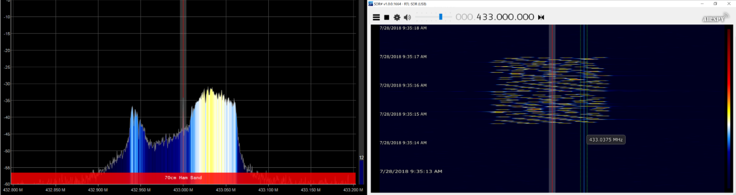
Figure 2: Spectrum analyzer view of the LoRa spread spectrum waveform. Left hand image shows the 125KHz bandwidth of the 300bps LoRa setting, while the righthand image shows a waterfall diagram of the LoRa transmission. While the righthand image partially shows the chirp modulation, the limited sample rate of the RTL-SDR (maximum 3.2Msps) provides a waterfall with a limited resolution, even with the FFT set to the minimum of 512 samples.

To determine the exact LoRa settings used by the device at 300bps, the transmitted waveform’s spectrum was analyzed. Using an RTL-SDR dongle and the Airspy application as a spectrum analyzer, the waveform of the device was analyzed. Figure 2 shows the results. The bandwidth of the waveform appears to be approximately 125KHz. Using the LoRa Calculator tool, a 300bps data rate is obtained with a bandwidth of 125KHz using SF=12. With these parameters, the receive sensitivity is estimated to be -138dBm.

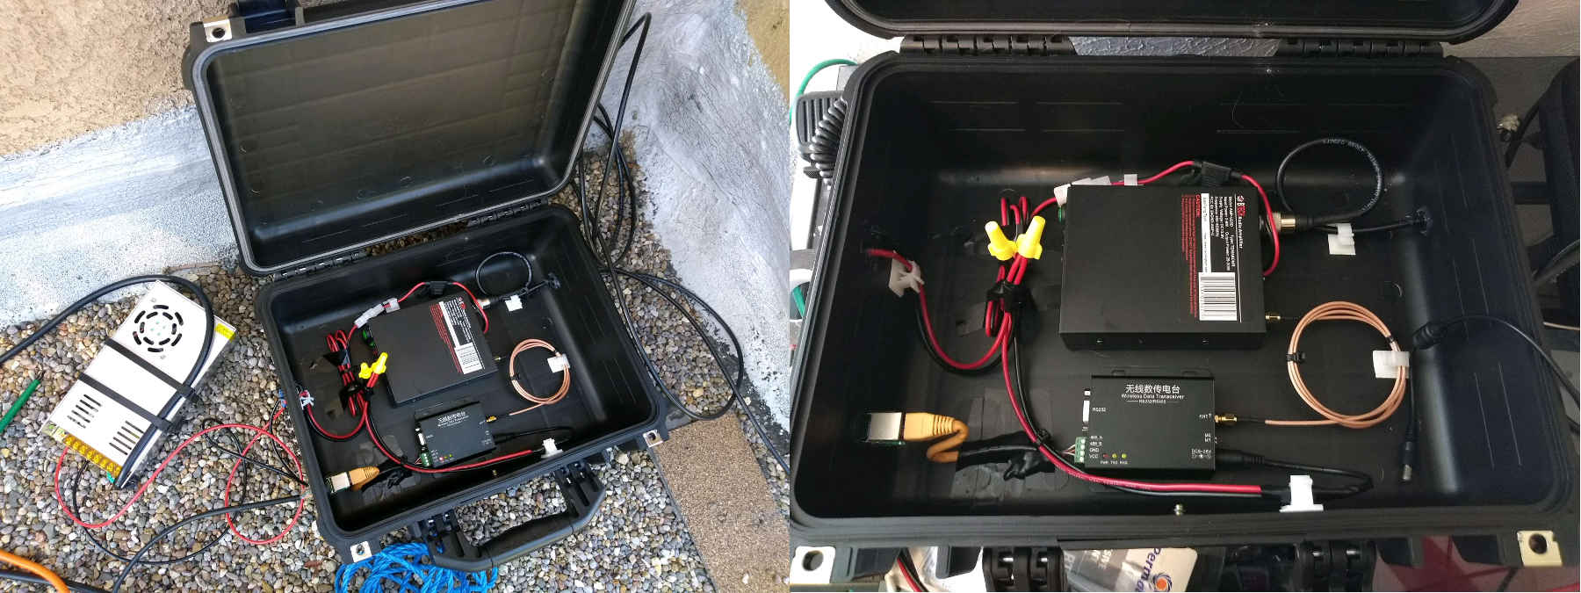
Figure 3: High power base station transmitter setup. While RS-485 communications were performed with the Category 5e cable, power had to be supplied by a nearby 12V power supply (silver metal box on left) due to the power demands of the 25W amplifier.
Two different transceivers were used for these experiments. For the high-power, receive-only tests, a 1W version of the CDEBytes transceiver was attached to a BTech AMP-U25D power amplifier, as shown in Figure 3. This amplifier was recently released by BTech as a power amplifier for HT’s, including TDMA-based DMR HT’s. It amplifies the 1W output of the transceiver to 25W. The transceiver is supplied with 13.8V from a modified 12V power supply. Data communications is provided by an RJ-45 connector that connects to a length of Category 5e cable to an Orange Pi Zero (a small Raspberry Pi-like board) with an attached USB-to-RS485 adapter. The second, low-power transceiver is like the high power one, except that it uses a 5W transceiver, and obtains power from the Category 5e cable. It is shown in Figure 4. A boost converter module raises the 12V supplied inside the shack to roughly 24V-30V to help overcome cable losses and supply enough power to the transceiver. Originally, an SO-259 panel connector was used for the RF connector, but after measuring a 1-2dB loss through it, RG-8x cable was run directly through the case. Both setups use Harbor Freight Apache weatherproof cases as enclosures.
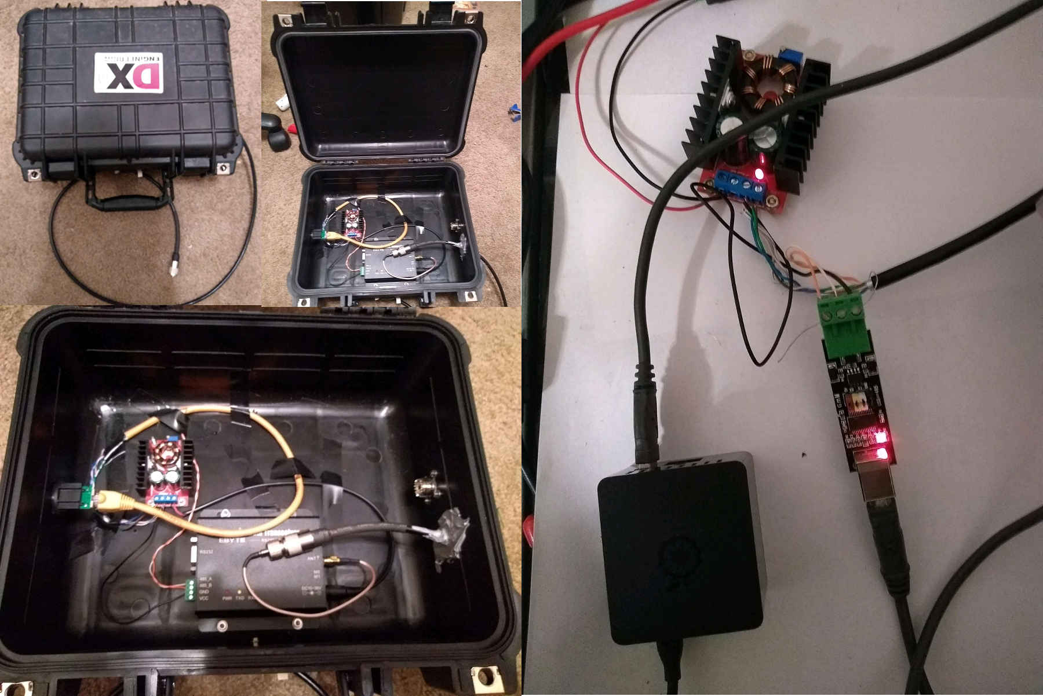
Figure 4: Low power base station transceiver setup. The RF transceiver was mounted outside, near the antenna to minimize the large feedline losses inherent to 70cm-band RF running over long lengths of RG-8x coax. Both RS-485 data and power were supplied over Category 5e cable running from the shack to the outdoor antenna on the other side of the house.
Both mobile setups are similar. The receive-only setup, shown in Figure 4, uses a 1W CDEByte transceiver. This transceiver was chosen because the transmit power can be reduced to <100mW (the 5W transceiver is fixed at 5W output). A lower power output allowed for safely connecting an LNA board without concern that an accidental high-power transmit might damage it. A low-noise amplifier (LNA) board with a claimed noise factor <1dB was originally planned to be used in the receive-only setup to try to reduce the 6dB noise factor specified by Semtech for the SX1276 transceiver chip; however, the LNA boards did not work at all. As a result, the experimental results in this paper did not use any external LNA.

The two-way setup replaces the 1W transceiver with a 5W one and uses a 12V/3A power supply, as the AA batteries used to power the 1W transceiver cannot supply enough power to the 5W transceiver. Both setups use a USB-RS232 cable for serial communications and a USB GNSS receiver to track the location of received packets. A small USB hub allows both devices to share a single USB connection to a laptop.
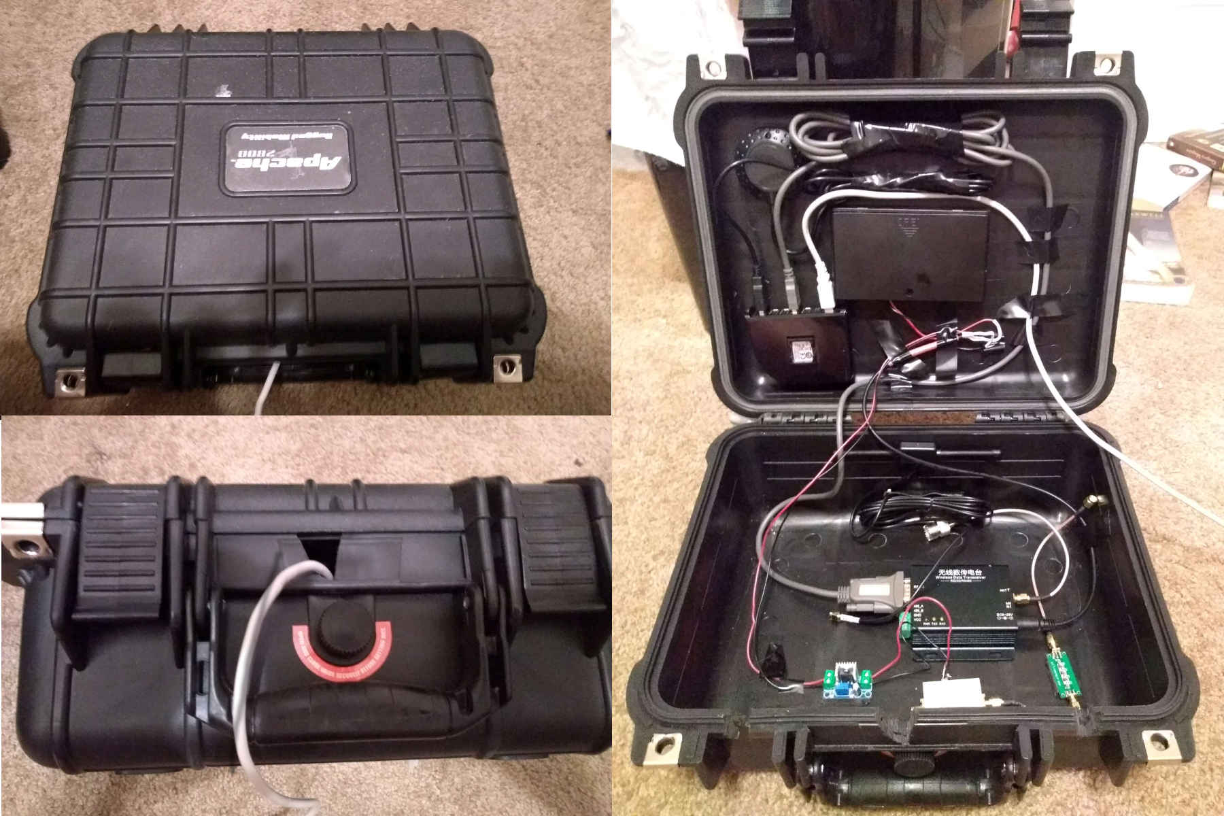
Figure 4: Receive-only mobile setup. The linear regular module (bottom-lower-left), LNA module (bottom-center-left), and 433MHz filter (bottom-lower-right) were not used for the experiments. 8 AA NiMH batteries powered the setup. A USB GNSS receiver provided location information to correlate with received packets.

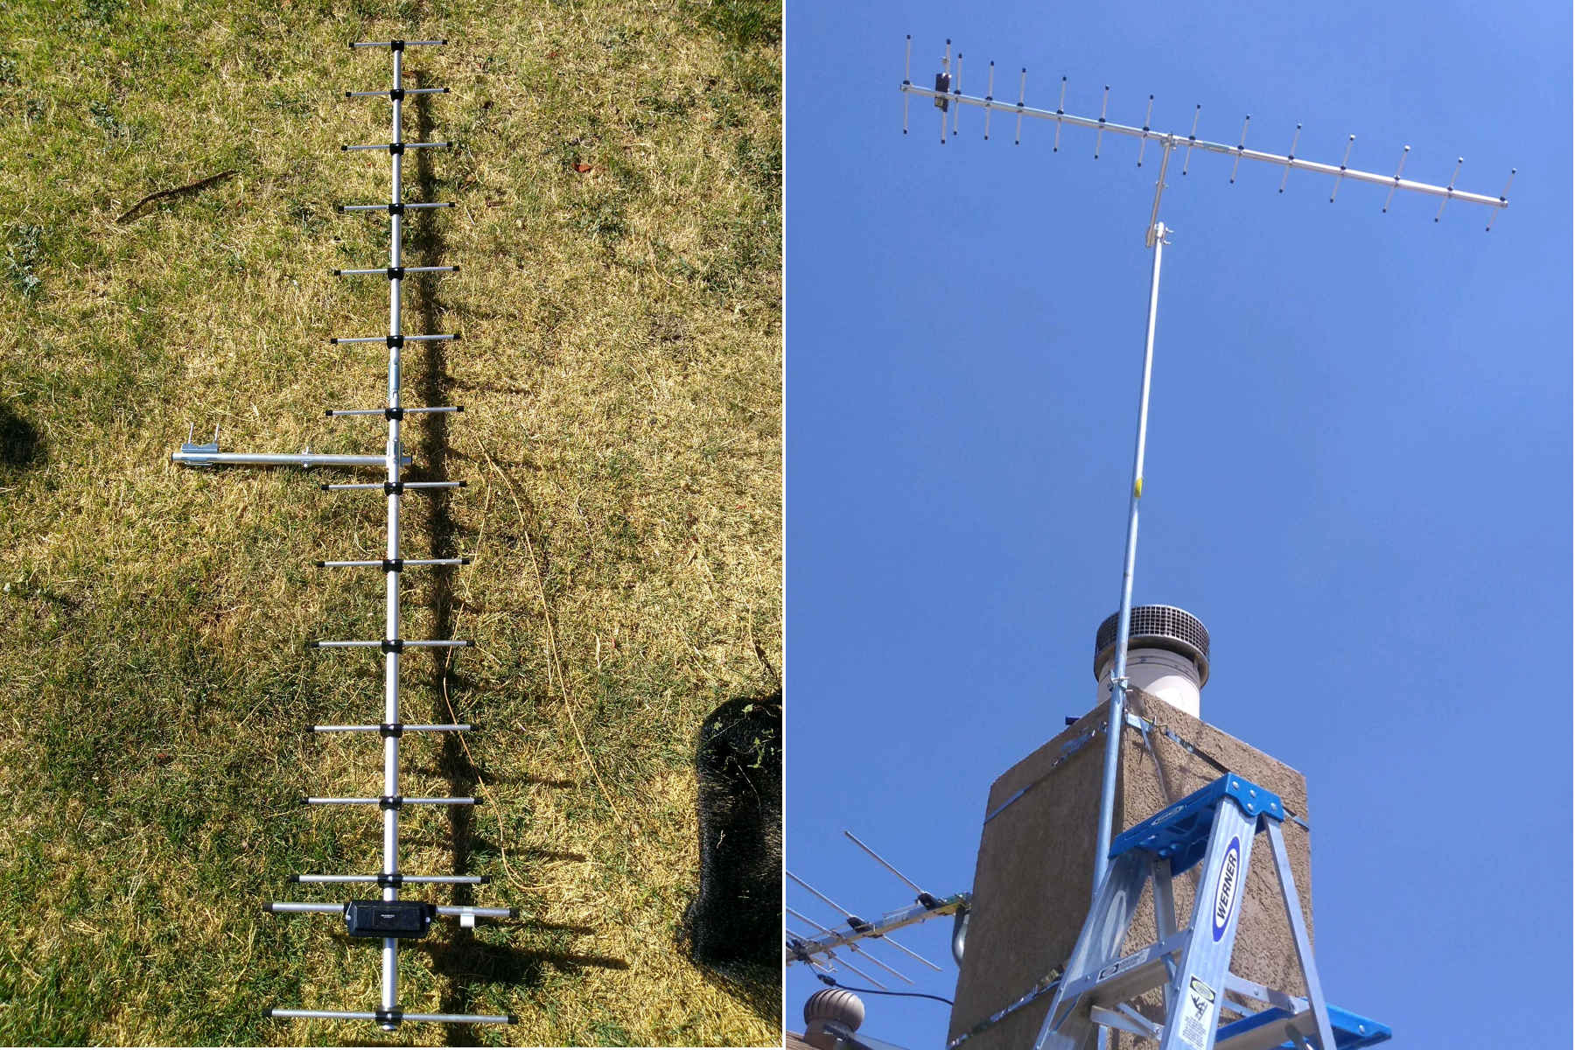
Figure 5: A Diamond 430s15 base station antenna was used for all the LoRa communications experiments.
Antenna System

The transmitting antenna, shown in Figure 5, is a Diamond 430s15 base station antenna. It is a fifteen element Yagi-Uda antenna with a manufacturer-estimated gain of 14.8dBi. It is mounted on the chimney of the author’s house using a 10’ length of 1” EMT conduit. It is mounted to the EMT conduit using Diamond’s KB430 antenna mount. This mount allows for mounting the antenna for both vertical as well as horizontal polarization. For the communication experiments conducted in this paper, the antenna is mounted horizontally. The antenna is mounted approximately 27ft off the ground. This height meets the minimum 7-10 wavelength height necessary to get the lowest radiation angle possible. The antenna connects to the transceiver via approximately 23ft of RG-8x coaxial cable, with low-cost PL-229 connectors at each end of the cable.

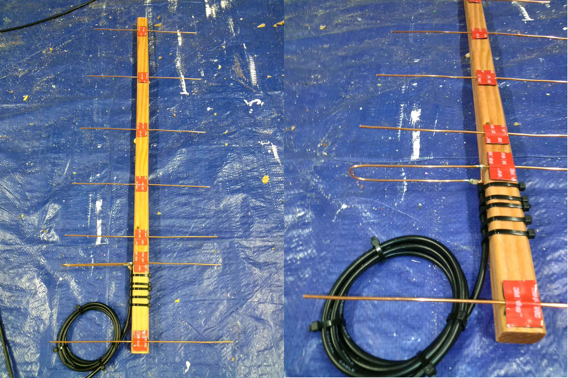
Figure 6: Portable Yagi antenna used for dismounted mobile experiments.

For stationary use, a 7-element Yagi antenna was constructed, shown in Figure 6. The basic design was developed using Changpuak's antenna calculator. A 2" wide, 36" long piece of wood was used as the boom, and the elements are constructed from #10 bare copper wire. The estimated gain was calculated to be 12.38 dBi. The driven element design is based off the folded impedance match described by WA5VJB. 11ft of RG-8x coax is used for its feedline.

For mobile testing, halo antennas were used, with the halo antenna being mounted to the roof of the rover. Halo antennas were used for the mobile experiments because they provide omnidirectional coverage in the horizontal plane with horizontally polarized radiation. Both halo antennas are derived from designs provided by KR1ST7, with the first design being a single-stack halo and the second design having two halo elements stacked vertically. Both halo elements were constructed from quarter-inch copper refrigerator tubing, with a small length of 10AWG copper wire for the gamma match. Both connections to the halo element (the gamma match as well as the coax shielding) connect to the halo element using hose clamps. Doing so allowed for adjusting the position of the gamma match to tune the antenna. 10ft of RG-8x coax was used for the feedline, with a PL-229 connector at the end.

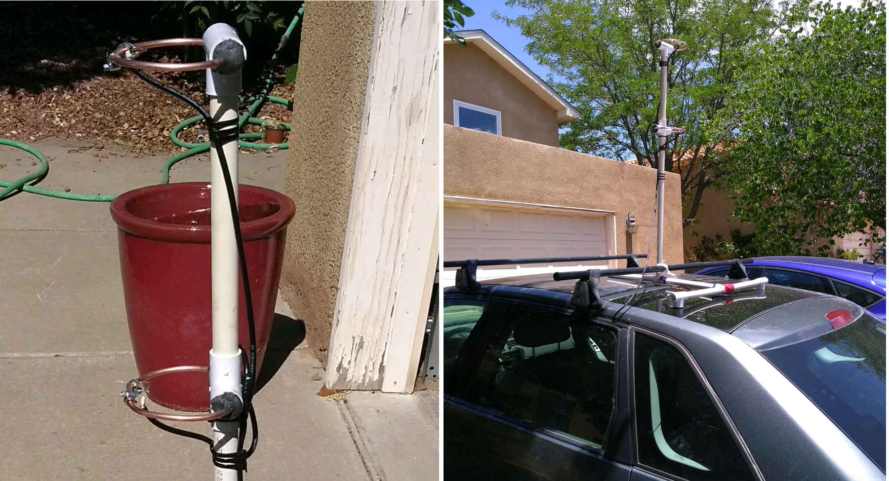
Figure 7: Mobile double-stacked halo antenna. The double-stacked halo antenna successfully received packets while the car was traveling at normal highway speeds down I-25S.

The halo elements were mounted using a setup based on ¾” PVC pipe. The halo element itself was mounted partially inside of a T-connector with duct mastic used to hold, seal, and secure the halo element to the PVC pipe assembly. The coax feedline was mounted to the PVC pipe using large nylon cable ties. For the dual halo antenna, two such halos were mounted, with both being constructed from quarter-inch copper refrigerator tubing, with a small length of #10 copper wire for the gamma match. The gamma match and the coax shielding connect to the copper tube halo with small hose clamps, which allows for tuning the antenna. The stacking harness used directly-connected RG-8x coax.
12ft of RG-8x coax was used for a feedline, and the antenna is mounted on a mast constructed of ¾" PVC pipe. The final setup is shown in Figure 7.

Digital communications setup

This radio link was tested in two ways. The first test was a one-way communication using UDP datagrams broadcast from the house at approximately 25W (44dBm). These UDP datagrams contained a message with the station’s callsign along with a count value that is incremented with each new broadcast to track missed packets. The receiver side would receive these datagrams and save them to a file along with a capture of the current GNSS location. Mobile reception was attempted in two ways: while the car is moving via a double-stacked halo antenna, and while dismounted using the portable Yagi antenna.

IPv4 was implemented over the RS485 serial port using SLIP. SLIP (Serial Line IP) is a protocol that provides a very simple Layer 2 framing for IP datagrams for transmission over a serial port. It was originally used for dial-up networking but was ultimately replaced with the Point-to-Point Protocol (PPP) in the 1990s. SLIP essentially does nothing more than frame IP datagrams with an escape character and provides a way to escape the escape characters when they appear inside of an IP datagram. While PPP is a more advanced protocol than SLIP, it is not well-suited for IP over a half-duplex serial interface. First, PPP expects by design a full-duplex serial port, so it is likely to have issues with half-duplex communication. Moreover, PPP provides various other features that are unnecessary, such as authentication, Address Resolution Protocol (ARP), etc., and likely to make the protocol brittle to non-standard uses.

For the one-way digital communications, the communication consists of periodically sending out a UDP packet with the callsign of the station. Initially, the callsign was the author’s callsign KG5VBY, but later, it used the callsign WM9XPW, which was granted for Special Temporary Authorization (STA), File Number 0721-EX-ST-2018. This STA gave permission to transmit LoRa spread spectrum communications at power levels up to 50W PEP from the base station. Normally, the FCC limits spread spectrum communications to 10W PEP. IP-based communication was chosen because it simulates realistic digital communications.

The second form of communication tested was two-way communication. For this test, both sides used 5W transceivers (the BTech power amplifier was not used because the STA only granted >10w PEP spread spectrum transmissions from the base station). The transmit and receive setups are otherwise identical to the one-way communication experiments. The two-way communication was tested by using the ping utility to exchange ICMP packets between the base stations and the rover. A reduced payload size (8 bytes instead of the 32 or more) compensated for the low communications data rate.

Link budget calculations

The link budget comprises, in dB, the maximum allowable path loss between two stations before digital communication between them fails. The link budget is the sum of the transmit power, transmit antenna gain, receive antenna gain, and receive sensitivity minus any losses in the system such as feedline and mismatch losses. Coax losses were obtained from C08TW’s coax line loss calculator. Link budget calculations are shown in Table 1. These figures show the large link budget that is capable from LoRa transceivers when power levels and antenna gain are increased using readily available amateur radio equipment. Further gains are likely possible by reducing feedline loss with lower loss coax such as LMR400 and/or using an external LNA to reduce the 6dB noise figure of the transceivers. Note that the antenna gain of the double halo antenna is estimated assuming that a single halo has a unity gain and stacking two provides an additional 2dB gain.

Table 1: Link budget figures for the communication configurations.
Path Component | Mobile Halo Setup Gain/(Loss) | Dismounted Yagi Setup Gain/(Loss) | Mobile TX/RX Gain/(Loss)
Tx power | 44 dBm | 44 dBm | 37 dBm
Tx antenna gain | 14.8 dBi | 14.8 dBi | 14.8 dBi
Tx feedline loss | (2.3 dB) | (2.3 dB) | (2.2 dB)
Rx sensitivity | -138 dBm | -138 dBm | -138 dBm
Rx antenna gain | 2 dBi (estimated) | 12.4 dBi | 2 dBi
Rx feedline loss | (0.97 dB) | (0.90 dB) | (0.97 dB)
Total Link Budget | 193.5 dB | 206.0 dB | 188.6 dB

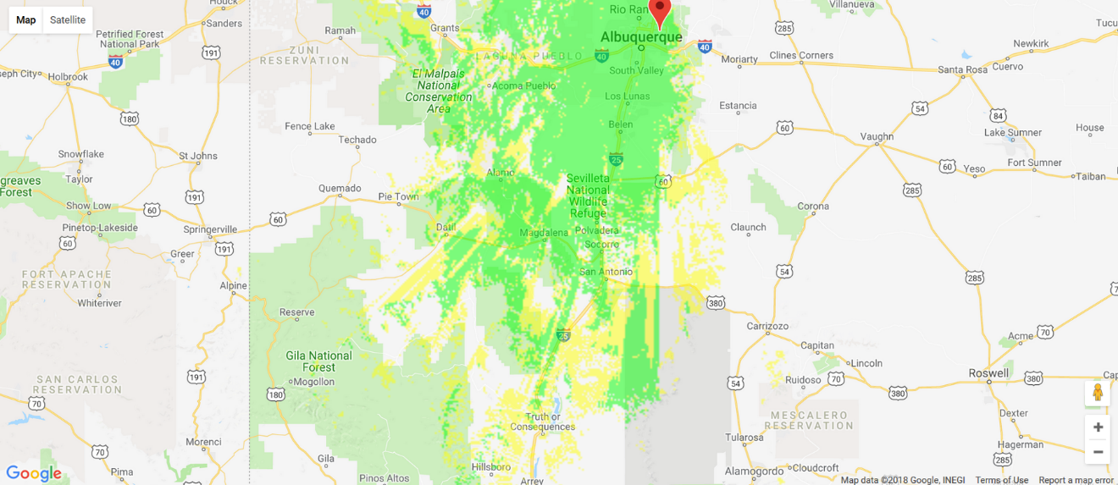
Figure 8: Coverage map for the high-power RX-only setup with the portable Yagi antenna. Green areas indicate areas with an excess link budget of 10dB or more, while yellow areas indicate areas with 0-10dB of excess link budget. The patch of green near Truth or Consequences was the receive location ultimately chosen to set the world record.
Modeled Coverage

Modeling the coverage was essential to determine which locations the signal could be received. Coverage was modeled with Radio Mobile Online. This tool allows for modeling coverages and specific transmission paths by inputting antenna configurations, power levels, receive sensitivities, and cable losses. Using these values, the tool can compute coverage information and estimated signal levels for both line-of-sight and beyond line-of-sight via diffraction and troposcatter. Specific point-to-point radio paths can be modeled as well as broader area coverages. Note that for the coverage figures, while the tool provides a Yagi antenna model and an antenna azimuth parameter, it requires a sophisticated antenna model to input new beam patterns. As a result, the coverage maps likely model a wider beam width than what the Diamond 430s15 antenna has.

Troposcatter path loss is strongly affected by the angle of radiation, with a single degree increase in the radiation angle causing a 10dB increase in path loss. As a result, visible terrain features such as mountains and hills can heavily increase path loss. The coverage map shows this effect in the form of “rays” of coverage. These “rays” are essentially small openings in Central/Southern New Mexico’s rugged terrain that allow shallow-angle radiation to scatter off the upper troposphere and be received at a shallow angle or diffract. This terrain-modulated, highly variable coverage demonstrates why it is critical to model coverage for troposcatter experiments, as two nearby locations can have completely different coverage levels. Finally, the irregular coverage shown in Figure 8 suggests that the LoRa communications record could be easily broken in a place with long stretches of flat terrain, such as the Central Plains or Midwest regions of the United States.
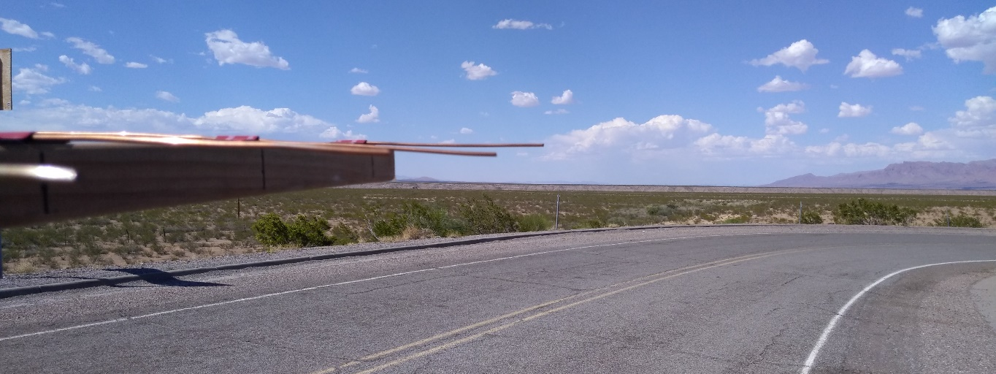
Figure 9: Setting the Ground-Based LoRa Record. The portable Yagi antenna is pointed directly at the horizon, between two groups of mountains.
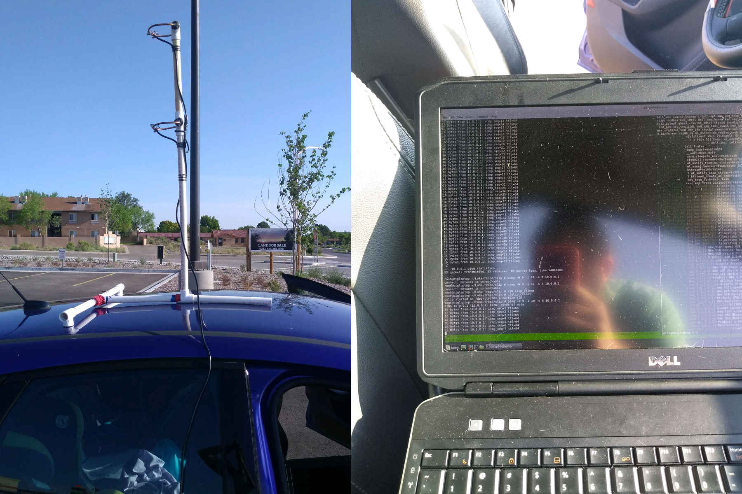
Figure 10: Testing TX/RX Communication in Belen, NM. The vehicle was not moving for these tests, and the mobile double-stacked halo antenna was used.
Experimental Results
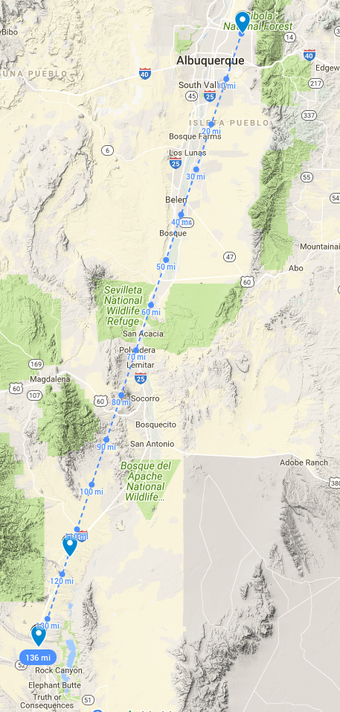
Receive-only communication was attempted with the car traveling at normal highway speeds, typically 70-75mph. Successful reception of LoRa packets occurred as far south as Socorro, NM. After that, the mobile setup did not receive any LoRa communications. The distance record was set near Truth or Consequences, NM in a spot with a clear view of the horizon with no interfering geographic features. A terrain map showing the location of the transmitting station in Northeast Albuquerque and the location of the received packets is shown in Figure 11. Note that terrain map shows that the signal path is relatively free of obstructing terrain features except for mountains near Socorro, NM. Using the path modeling tool from Radio Mobile Online, the BLoS propagation is likely caused by diffraction across the tops of the mountains near Socorro. The location was measured to be 136 miles, or 218 km, from the transmitting location using Google Maps’ distance measurement tool.
The two-way communications test tested two-way digital communications at lower power from a shorter distance. The main purpose of this quick test is to make sure that BLoS LoRa communications are possible in both directions. Successful two-way communications were demonstrated using the ping utility. The distance between the two stations was measured to be 38 miles (61 km) using Google Maps’ distance measurement utility.
Related work

Others have set and attempted to set distance records using LoRa-based communications. All these records are based on various forms of Line-of-Sight (LoS) communication, which makes the work in this paper novel in that it sets a distance record in a Beyond Line-of-Sight (BLoS) manner. The first record is a ground-based record set by Andreas Spiess, where he climbed up one mountain and was able to hit a Things Network station on another mountain 201km away. The next record involved a high-altitude balloon record set in Europe where a LoRaWAN packet sent from a high-altitude balloon was received 702km away at a Things Network station in Poland. Both records used LoRa in a “conventional way” in that it operated at standard LoRaWAN power levels and frequencies (in these two cases, the 868MHz band, since both records were set in Europe). Finally, there is a satellite-based IoT system that uses the LoRa waveform in a Software-Defined Radio to convey modest data rates via Ku-band satellite repeaters.
Figure 11: Map showing the location of the transmitting station and the location where the record-setting packet reception occurred. The terrain map shows that the signal path is relatively tree of terrain features except for mountains near Socorro. For this particular signal path, computer modeling suggests that the likely propagation path involves diffraction off of the tops of the mountains near Socorro.

Another study looked at LoRa communications in Antarctica on both 433mhz and 868mhz. It was able to demonstrate moderately long distances in the range of 20-30km using default LoRa power levels. Testing involved a rover with a 6dBi vertical antenna and Yagi antennas at the base station.

Future Work

All these experiments were conducted using horizontal polarization. Horizontal polarization was chosen by the author because weak signal VHF+ amateur radio DX work is always done with horizontal polarization. It is not known with certainty to the author, however, how advantageous horizontal polarization is versus vertical polarization for BLoS communications. As a result, future work will investigate horizontal versus vertical polarization. Other important areas of exploration include testing the link at different data rates as well as characterizing communication reliability. The author plans to ultimately continue exploring LoRa communications using 1W HopeRF RFM98PW modules that allow for direct, low-level access to the SX1276 LoRa transceiver’s registers. Direct access to the device allows for obtaining information such as Received Signal Strength Indication (RSSI) information as well as the ability to tinker with and fine-tune LoRa parameters.

Another avenue of future work that the author plans to pursue is applications for long-distance LoRa communications. Future experiments may include attempting to send voice communications over a BLoS LoRa link using low data rate codecs like codec2. Another potential avenue of experimentation is to study the potential for a very wide-area mesh network with sparse numbers of stations and troposcatter/diffraction-based intercity links.

Conclusion

While designed for small, battery-powered Internet-of-Things devices, the Semtech LoRa waveform is also useful for longer distance communication, including Beyond Line-of-Sight (BLoS) communications. LoRa devices use a form of Chirp Spread Spectrum to allow for very high receive sensitivity at lower data rates (e.g., -138dBm at 433MHz and 300bps). When augmented with higher transmit power (5W or more) and high gain antennas, it is possible to obtain a large enough link budget to provide successful packet radio communications at beyond line-of-sight distances using propagation methods such as diffraction and troposcatter.

References

“LoRaWAN™ Specification v1.1”, https://www.lora-alliance.org/resource-hub/lorawantm-specification-v11, accessed August 3, 2018.
“Long Range, Low Power, 2.4 GHz Transceiver with Ranging Capability”, https://www.semtech.com/uploads/documents/DS_SX1280-1_V2.2.pdf, accessed July 31, 2018.
“LoRa Transceivers”, https://www.semtech.com/products/wireless-rf/lora-transceivers, accessed August 4, 2018.
“VHF Troposcatter Propagation - VHF102”, http://www.nmvhf.org/kk6mc.ppt, accessed September 16, 2018.
“CDEBYTE”, http://www.cdebyte.com/en/, accessed May 12, 2018.
“LoRa Calculator: fast evaluation of link budget, time on air and energy consumption", https://www.semtech.com/uploads/documents/SX1272LoRaCalculatorSetup1_1.zip, accessed May 12, 2018.
Alexander C. Frank, “Yagi Uda Antenna Calculator”, https://www.changpuak.ch/electronics/yagi_uda_antenna_DL6WU.php, accessed May 12, 2018.
Kent Britain WA5VJB, “Controlled Impedance ‘Cheap’ Antennas”, http://wa5vjb.com/yagi-pdf/cheapyagi.pdf, accessed May 12, 2018.
Alex Krist, “A Halo 4 Stack for 70cm on the Cheap”, http://www.kr1st.com/70cmstack.htm, accessed July 11, 2018.
“Types of Coax Cable and Line Loss Calculator”, http://www.qsl.net/co8tw/Coax_Calculator.htm, accessed August 3, 2018.
Roger Coude, “Radio Mobile Online”, http://www.ve2dbe.com/rmonline.html, accessed May 12, 2018.
Andreas Spiess, “#120 LoRa / LoRaWAN Range World Record Attempt. Will I succeed?” https://www.youtube.com/watch?v=adhWIo-7gr4, accessed May 12, 2018.
The Things Network Global Team, “Ground breaking world record! LoRaWAN packet received at 702 km (436 miles) distance”, https://www.thethingsnetwork.org/article/ground-breaking-world-record-lorawan-packet-received-at-702-km-436-miles-distance, accessed May 12, 2018.
Jenny List, “At 71,572 KM, You Won’t Beat This LoRa Record”, https://hackaday.com/2018/02/22/at-71572-km-you-wont-beat-this-lora-record/, accessed July 31, 2018.
Gaelens, J.; Van Torre, P.; Verhaevert, J.; Rogier, H. “LoRa Mobile-To-Base-Station Channel Characterization in the Antarctic”, Sensors 2017, 17, 1903.
“RFM98PW/RFM95PW Enhanced Power Long Range Transceiver Module”, http://www.hoperf.com/upload/RFM98PW_RFM95PW%20RF%20Transmitter%20and%20Receiver%20Module%20Datasheet%20REV1.1.pdf, accessed August 4, 2018.

